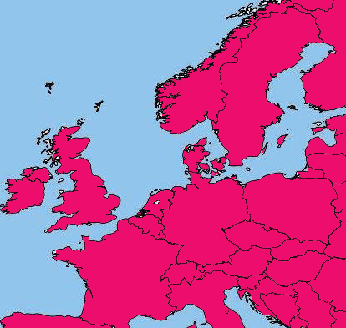
Manasseh

The Lost Tribes, around 1500 AD

(Map by Bert Otten)

